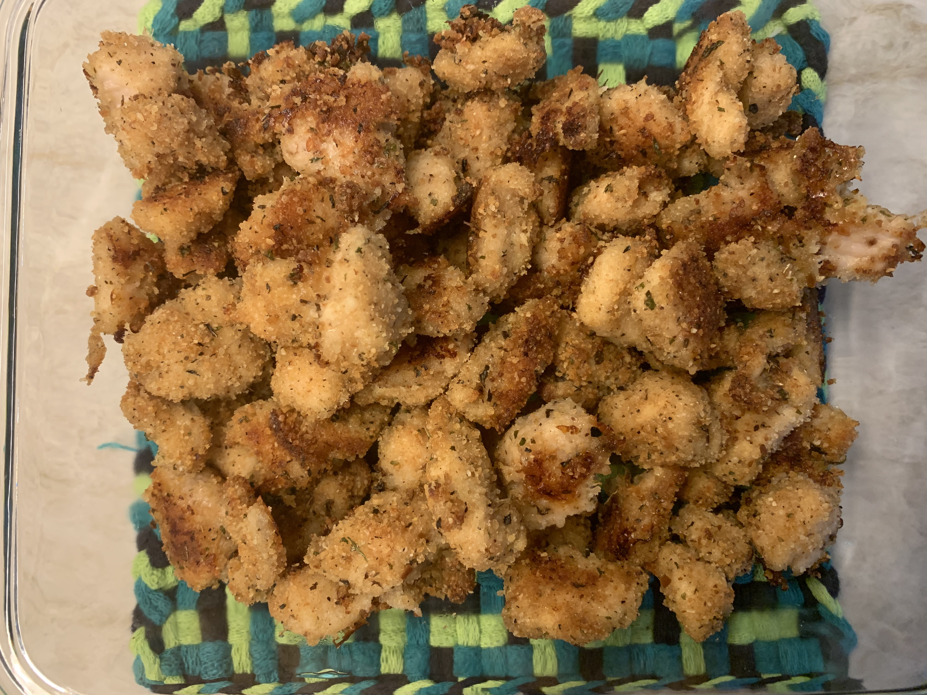
Baked Chicken Nuggets
www.allrecipes.com
Submitted by: Teresa

Yield: 3 servings

" A Parmesan crust lifts these chicken nibbles above the ordinary. Serve alone or with an array of dipping sauces."

INGREDIENTS:

- 1 skinless, boneless chicken breast
- 1/3 cup Italian seasoned bread crumbs
- 2 Tablespoon grated Parmesan cheese
- 1 teaspoon dried basil
- 1/4 teaspoon pepper
- 1/8 teaspoon dried thyme
- 1/8 teaspoon salt
- 3 Tablespoons butter, melted

DIRECTIONS:

- Preheat oven to 400 degrees F.
- Trim fat from chicken breasts with knife or kitchen shears.
- Cut chicken breasts into 1 inch size pieces.
- In a gallon plastic bag, mix together the bread crumbs, cheese, basil, pepper, thyme and salt.
- Melt butter in batter bowl for approximately 30 seconds – be sure to cover with wax paper to avoid splatter.
- Place chicken in batter bowl and stir to coat.
- Add chicken to the seasoning bag. Close and shake to coat the nuggets. Be sure all nuggets are evenly coated and there is no seasoning left loose in the bag.
- Line a baking sheet with parchment paper.
- Place chicken on baking sheet (lined with parchment paper) – spread apart in a single layer.
- Bake for 20 minutes.

